Text and Visual Annotation Tools for Scalable Design Feedback Generation

| 1st Author Name  Affiliation  City, Country  e-mail address | 2nd Author Name  Affiliation  City, Country  e-mail address | 3rd Author Name  Affiliation  City, Country  e-mail address |
| --- | --- | --- |

# ABSTRACT

Paste the appropriate copyright/license statement here. ACM now supports three different publication options:

* ACM copyright: ACM holds the copyright on the work. This is the historical approach.
* License: The author(s) retain copyright, but ACM receives an exclusive publication license.
* Open Access: The author(s) wish to pay for the work to be open access. The additional fee must be paid to ACM.

This text field is large enough to hold the appropriate release statement assuming it is single-spaced in Times New Roman 8-point font. Please do not change or modify the size of this text box.

Each submission will be assigned a DOI string to be included here.

Use of crowd feedback systems has been shown to lead to improved visual designs. But there is little research on the relationship between characteristics of the feedback collection interface and nature of the feedback collected. … results …

## Author Keywords

Crowdsourcing; design; feedback; creativity.

## ACM Classification Keywords

H.5.3 [Information Interface and Presentation]: Group and Organization Interfaces – Collaborative computing.

# INTRODUCTION

Collecting and addressing feedback are vital steps in the iterative design process. Generated insights help guide designers towards artifacts that better connect with the target audience [1]. Crowd feedback services offer several advantages over alternatives, and are attractive because of their scalability, availability, and affordability [2, 3]. However, one challenge these services encounter is that crowd workers rarely possess skills in specialized domains such as design [4].

To combat this, scaffolding is often employed to provide support to learners as they attempt a novel task. One scaffolding strategy that helps learners express themselves is the use of different media and modes of expression in the interface [5]. A number of crowd feedback systems have implemented this strategy resulting in enhanced quality of collected feedback [3, 6, 7]. This feedback has been shown to lead to improved designs [2].

However, introducing scaffolding into a system may significantly affect people’s behavior by introducing framing effects [8]. For example, asking a feedback provider to annotate a visual design requires them to visually search the design and focus their attention on specific details [3, 9]. Revealing previous feedback to a feedback provider, while encouraging novel ideas, may also encourage conformity [10, 11]. It is therefore important for researchers to understand the relationship between characteristics of the feedback collection interface and the resulting feedback to develop effective scaffolding in crowd feedback systems.

In this paper, we present four interfaces for soliciting design feedback and study characteristics of the collected feedback in each condition. In our experiment we manipulate input type and presence of history to create our interfaces. Modality conditions reflect real-world feedback collection interfaces such as Reddit and Red Pen [12-14]. Meanwhile, the history condition represents another design decision that must be made during the creation of a feedback collection interface that could have important implications on the resulting feedback [15].

We then recruit human participants to provide feedback on visual designs using one of the interfaces. We investigate how choosing a text or annotation feedback input and hiding or revealing history impacts feedback content including number of discrete elements of design referenced and degree of conceptuality. These relationships are explored across a variety of visual designs (poster, static website, and web interface).

# Related work

## Feedback Collection Tools

There are many different classes of feedback collection tools for collecting design feedback in an online context. Tools such as Redpen.io and Adobe Acrobat require a feedback provider to first select a region of the design before they are able to enter feedback [13, 16]. This is in contrast to tools such as Reddit and Dribble which do not require the feedback provider to annotate the design before they are able to begin generating feedback [12, 14].

In using Adobe Acrobat or email in generating feedback for a specific design, feedback providers have no access to the history of feedback that the design might have already received. Tools such as Redpen.io and Reddit however reveal to the feedback provider the history of feedback that the design has already generated.

However, there is no prior work on how these different classes of feedback collection tools influence the feedback generated. Our work addresses this gap.

## Studies of Crowd Feedback Systems

A number of studies have been conducted studying the benefit of crowd feedback in the design process. The use of crowd feedback systems has been shown to lead to improvements in designs [2]. Systems such as Voyant and CrowdCrit have shown that useful feedback can be generated even from non-expert crowds [3, 6]. Critiki introduced a system that simplified the process of creating, distributing, and aggregating crowdsourced design critique [7].

But what none of these studied did is compare spatial and non-spatial interfaces. These systems also do not grant feedback providers access to history feedback that others have generated for the same design. In our work, we collect empirical evidence on how these factors influence the generated feedback. This knowledge will provide crowd feedback system implementers with insights on how their design decisions influence the generated feedback.

# Methodology

Our study compared how two classes of Feedback Interface (spatial and non-spatial) and History (absent or present) influence generated feedback. We seek to answer the following questions concerning these aspects of the interface: whether they cause the provided feedback to be more specific or more general, if they influence the likelihood of generating a certain category of feedback, and if the presence of history introduces a fixation effect.

These questions are not exhaustive but are intended to give designers a better sense as to how their choice of feedback collection tool will influence feedback received online. The results may also create awareness among system developers as to how their implementation choices influence the feedback exchange.

## Experimental Design

To answer these questions, we conducted a full-factorial, between-subjects experiment. The factors were Interface (Non-spatial vs. spatial) x History (Absent vs. Present) x Design Category (Poster vs. Webpage vs. Web Interface), giving a 2x2x3 design.

## Participants

Feedback providers (N=360) were recruited from Mechanical Turk. To participate, providers were required to have successfully completed at least 50 tasks and to have a task approval rate greater than 95%. **Insert demographic** **data here**. Based upon a pilot study, they payment was set at $0.50 per task to reflect current US minimum wage.

## Designs

We chose three designs, selected to span a broad range of visual domains, to be familiar to a general audience, and to warrant design improvements. The selected designs included a poster advertising a university dance event, the home page of a community college (<http://parkland.edu>), and a web-based payment application (<https://venmo.com/>). Explicit permission from the creator



**Figure 1. The interface for leaving feedback in the spatial condition. A Provider can leave a comment by selecting a region on the design and entering text in a window. They could leave as many comments desired and were allowed to look at the history by hovering existing markers.**

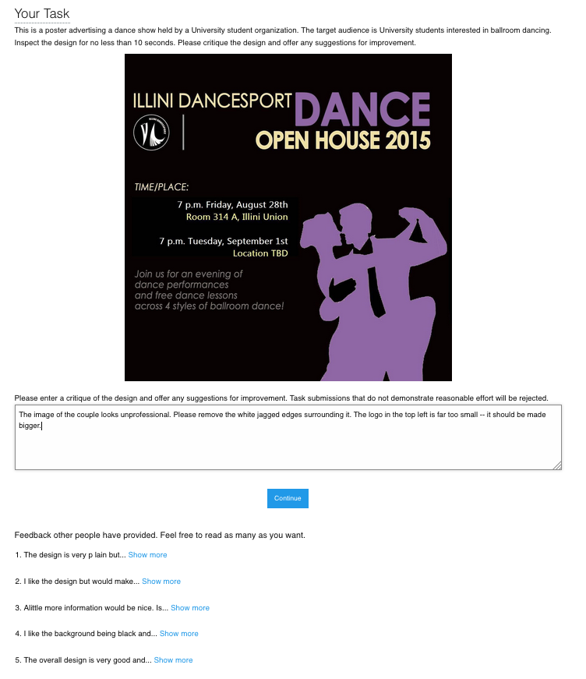

**Figure 2. The interface for leaving feedback in the non-spatial condition. A feedback provider enters their feedback in a text area. In the history condition, feedbacks left by previous providers were visible. The participant may choose to view the full feedback by selecting ‘Show more.’**

of the first design was obtained and the two remaining designs were public domain.

## Feedback Interfaces

The feedback interface features a block of text introducing the task and includes a brief description of the design and its target audience. The design is then prominently displayed.

In the non-spatial Interface, a text area prompting the provider for feedback was below the design image. A submit button was placed next to the text area to complete the task. In the presence of the history, past feedback was displayed underneath this form. Rather than pre-generating history, we mimicked real world systems by allowing the history to grow organically from feedback submitted by previous providers. The presentation of the history was based on how online platforms such as Reddit or Dribble function, where the provider has access to an evolving history [12, 14]. We adapted this format however to include a “Show more…” interaction which allowed us to log which pieces of feedback were viewed.

In the spatial Interface, the feedback provider first selects a location on the design and is then prompted to enter feedback in the window that appears. The feedback is committed by pressing elsewhere on the image. A visual marker representing the feedback is then overlaid on the design to represent the feedback left at the location. The provider could leave as many pieces of feedback as desired, inspect the feedback they had left by hovering over the associated visual marker, and could always edit their own feedback by clicking a marker. In the presence of the History, the pieces of feedback left by previous providers were shown. The participant was allowed to hover over any visual markers to reveal the annotated feedback. Otherwise, the interface operated the same as the History absent condition. The spatial condition was designed and implemented to reflect popular annotation feedback tools such as Adobe Acrobat and Red Pen [13, 16]. Once satisfied with the feedback, the provider submitted their work.

## Procedure

Upon accepting the task, the feedback provider was presented with a consent form. If accepted, they were randomly assigned to one of 12 experimental conditions. The experimental conditions were implemented in JavaScript and the feedback provider did not have to leave the Mechanical Turk platform. In each condition, they read the task instructions, viewed the design, and entered feedback based on the interface condition assigned. After entering feedback in the interface provided, they submitted their work and completed a brief survey.

## Measures

The study consisted of three sets of measures: content analysis, behavioral measures, and self-assessment.

*Content analysis*

For content analysis, we calculated specificity, categorized the feedback content, and measured general metrics such as its length.

A measure of specificity was calculated for each feedback response. Specificity was measured using the NLTK toolkit. The toolkit calculated specificity by determining how deep each word appears in the Wordnet structure. Words closer to the root are more general (e.g. “dog”) while deeper words are more specific (e.g. “Labrador”). In calculating sentence specificity, stop words and punctuation were ignored. The specificity metric was normalized to range from 0.0 to 1.0. In the past, other researchers have used this technique [4].

To categorize the feedback content, each feedback response was partitioned into individual idea units. An idea unit represents a coherent unit of thought. The idea units were then coded based upon a taxonomy of critique discourse [17]. For example, the taxonomy included categories for judgement (*“I like that sketch but not that design. I don’t like this up here because it looks paperish—you know, not ceramic.”*) and interpretation (*“There’s a whole mysterious quality. There’s a shadow and a mystery, and you wonder, what’s going on in there?”*).

Two coders with experience in HCI categorized each idea unit according to the taxonomy. In total, 1206 idea units were categorized. Cohen’s Kappa, a measure of reliability between multiple raters, was 0.81 on 80 training samples (5% of the dataset). Coders were paid $25 for their effort.

Additionally, we measured feedback text length by cumulative character length of all feedback from a single provider.

*Behavioral measures*

For behavioral measures, we calculated the similarity between generated feedback and history feedback and computed general behavioral metrics. A provider’s interactions with prior feedback were logged. For the spatial condition, we logged each time the provider revealed a previous feedback by hovering over a visual marker. Likewise, in the non-spatial condition, we logged each time the provider selected a ‘Show more’ link.

Next, for each provider, we aggregated the set of prior feedback that they viewed. For each comment that a provider left, we aggregated the set of feedback they had viewed up to that point. We computed the distances between the recent comment and history feedback using the cosine similarity similarity metric as implemented in the Python pattern.en toolkit.

We also measured behavioral metrics such as task completion time, number of prior feedback responses revealed, and number of feedbacks provided. These measures help us understand how different interface conditions affected the behavior of feedback providers.

*Self-assessment*

Following the feedback task, the provider completed a self-assessment survey. Providers rated their design expertise, perceived effort, and perceived usefulness of the feedback given on a five point Likert-scale, with a score of 5 as the most favorable. The survey also included two questions for demographics (age and gender).

# Results

In total, 30 responses were collected per experimental condition for a total of 360 responses. We reviewed all the submissions and excluded any that were irrelevant or incomprehensible. 3 submissions were excluded, leaving us with 357 feedback responses of reasonable quality.

**Content Analysis**

*Non-spatial condition produced longer feedback*

An ANOVA revealed that Interface had a main effect on feedback length (F(3,357)=7.86; *p*=0.0053). Character count per condition can be seen in Figure 2. Pairwise comparison using Tukey’s HSD showed that the length of the feedback in the non-spatial condition (*μ*=269.7 characters) was longer than the feedback from the spatial condition (*μ*=217.4; *p*=0.0051). No other effects were discovered.

The non-spatial condition may have led to longer feedback due to the need for use of deixis, i.e. words or phrases such as “here” or “there” that require further contextual information to be understood but eliminate the need for explicit description of the visual elements referenced by feedback.

*Different conditions produce different categories of feedback*

After categorizing the idea units from generated feedback, we performed z-tests for population proportions to look for patterns of interest. Table 1 shows the breakdown of idea unit categories per condition.

We found that the spatial Interface generated more *investigations* (4.1%) than the non-spatial Interface (1.1%; *z*=3.23; *p*=0.001). An *investigation* is when a feedback provider asked questions about a specific piece of the design. Requiring the feedback provider to select a location on the design before entering feedback may cause him scan through various aspects of the design before performing feedback entry.

No other significant results were discovered, opposite of our expectations.

*Non-spatial feedback had more stop words*

An ANOVA did not detect a main effect of Interface or History on feedback specificity. In the spatial condition, mean specificity was 0.34 (*σ* = 0.17), while the non-spatial condition had a mean specificity of 0.37 (*σ* = 0.14).

An ANOVA uncovered a main effect of Interface on stop word count (F(3,357)=6.93; *p*=0.0089). Figure 1 summarizes stop word count. Tukey’s HSD showed that stop word count in the non-spatial condition (*μ*=27.31) was greater than the spatial condition (*μ*=21.98; *p*=0.0084).

One explanation for this is that the context provided by the spatial condition reduced the need for language necessary to convey the same information in the non-spatial condition. In the non-spatial condition, stop words were used to reference specific elements of the design: *“The logo must come at top before title and it must be large. The sentence written at the bottom should be brightened… There should be a name and contact details of a person to contact.”* Providers neglected these words in the spatial condition: *“Unappealing shade of purple. Perhaps more distinctness between the two silhouettes – looks kind of blobby right now. Maybe use bullet points.”*

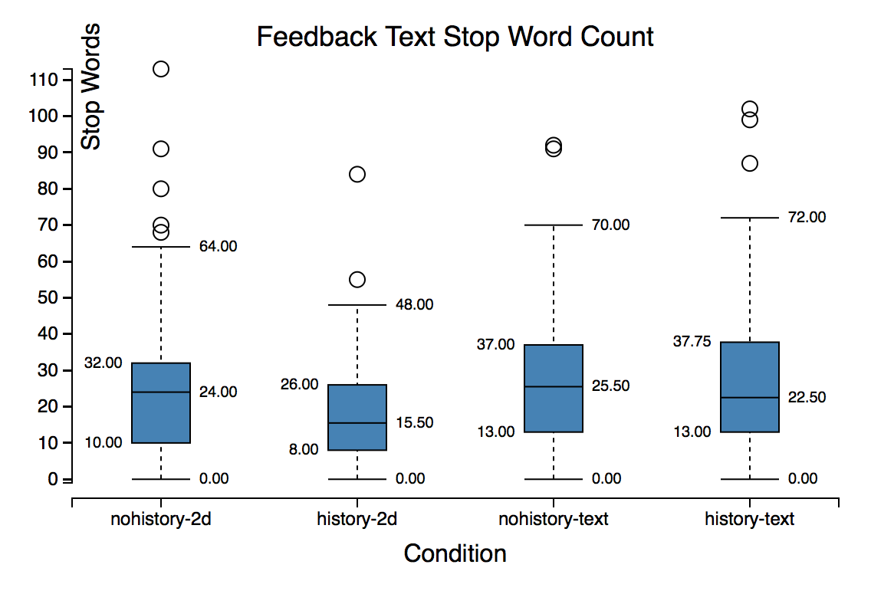

**Figure 1. This chart shows how the experimental condition affected stop word count of the feedback content. Analysis show providers included more stop words in their feedback in the non-spatial condition.**

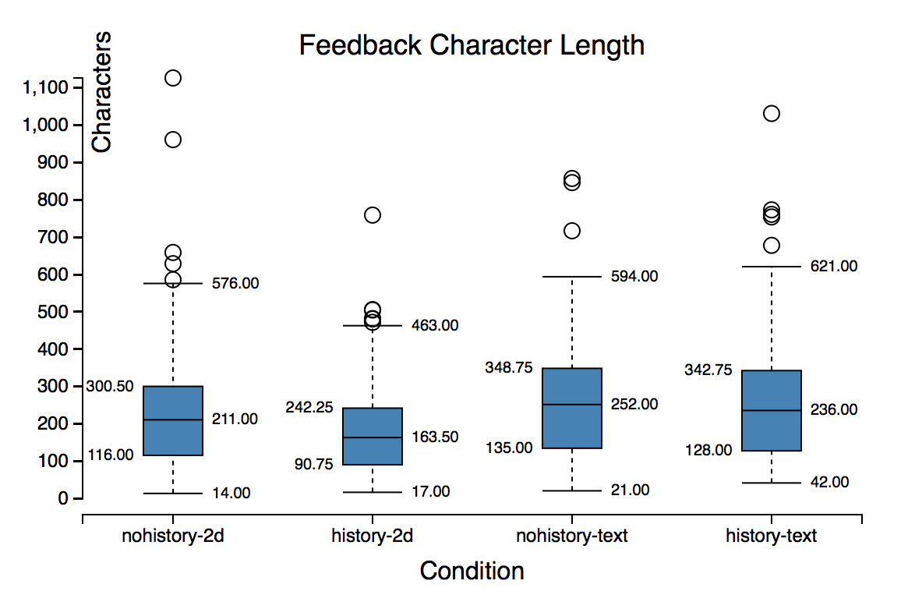

**Figure 2. The effect of experimental condition on length of feedback content is shown in this chart. Analysis shows providers left longer feedback in the non-spatial condition. No other effects were found.**

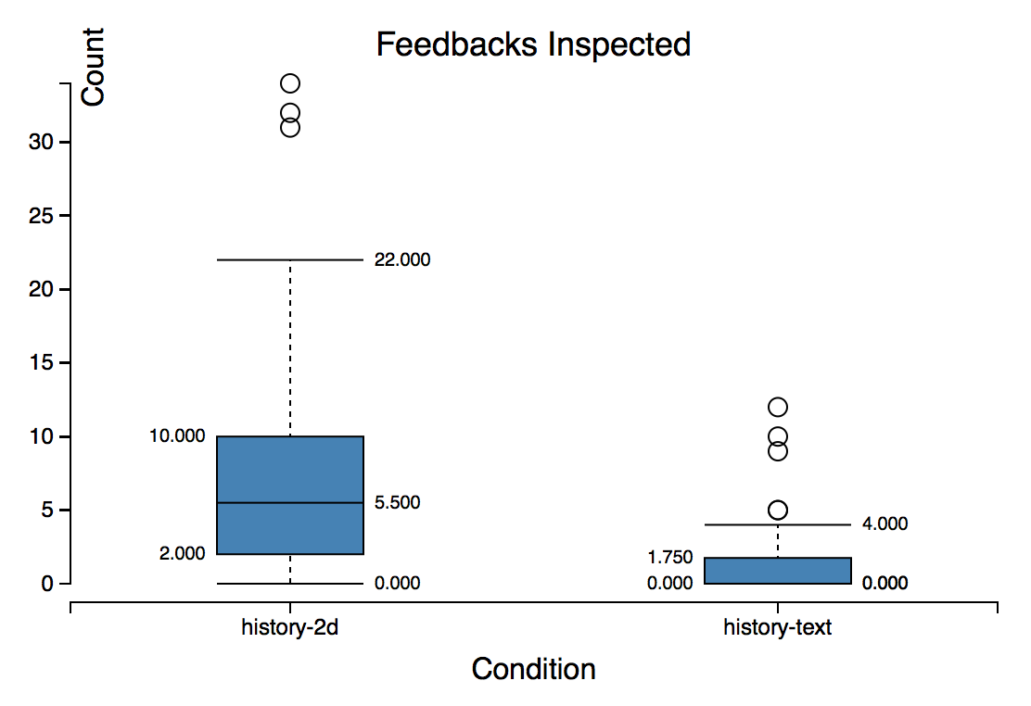

**Figure 3. This chart shows the count of instances of History condition feedbacks inspected by Interface. Analysis shows providers inspected more feedback instances under the visual condition.**

**Behavioral Measures**

*Providers inspect more feedback in spatial Interface*

When History was presented in the spatial Interface, we found 55% of providers (99 providers) inspected history feedback. When History was presented in the non-spatial Interface, we found 19% of providers (33 providers) inspected history feedback. The number of instances of feedback inspected by providers is visualized in Figure 3. An ANOVA revealed a main effect of Interface on instances of feedback inspected (F(3, 180)=60.57; *p*=0.0001). Tukey’s HSD showed that spatial Interface providers inspected more feedback instances (*μ*=7.29) than the non-spatial condition (*μ*=1.14, *p*=0.0001).

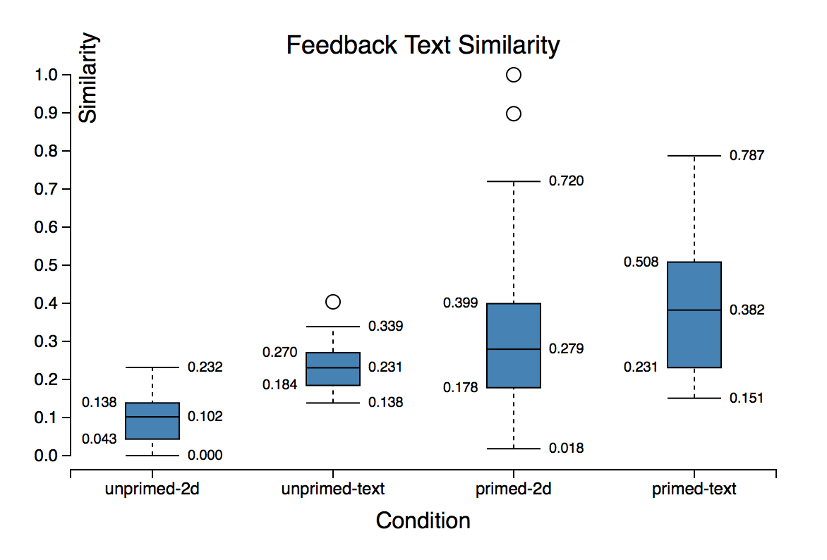

**Figure 4. Similarity scores of generated feedbacks compared to viewed and unviewed history by condition. Generated feedback was more similar to viewed history.**

One explanation for this effect is the cost of access of history feedback in the non-spatial Interface relative to the spatial condition. Providers in the spatial Interface didn’t have to scroll and didn’t have to click a ‘Show more’ link to unveil history feedback.

*Generated feedback was more similar to viewed history*

We only considered instances of generated feedback where the provider had examined the history. This left us with 200 instances of feedback in the spatial condition and 42 instances of feedback in the non-spatial condition. Figure 4 displays feedback similarity scores.

An ANOVA showed that when a provider generated feedback, the feedback was more similar to the history that the provider looked at (*μ*=0.11) than it was to the history that the provider did not look at (*μ*=0.044; F(3,232)=26.59; *p*=0.0001). Tukey’s HSD deemed this difference significant (*p*=0.0001).

This suggests that presence of a History introduces a fixation effect for the feedback providers. This effect is analogous to how pictorial representations of examples introduce a fixation effect when solving design problems [18].

*Non-spatial feedback was more similar to viewed history*

An additional main effect revealed by ANOVA was the influence of Interface on similarity to viewed history (F(3,230)=12.88; *p*=0.0004). Tukey’s HSD showed that similarity to viewed feedbacks in the non-spatial condition (*μ*=0.11) was higher than that of the spatial Interface (μ=0.069; p=0.0039). This effect is visible in Figure 3.

This effect may have been due to the non-permanence of the feedback window in the spatial Interface. This interface required the feedback provider to hover over a marker to reveal the content. This was in contrast to the non-spatial Interface where an inspected feedback remained visible until the provider explicitly chose to hide it.

|  |  |  |
| --- | --- | --- |
| **Effort Self-assessment** | | |
|  | Non-spatial | Spatial |
| History Absent | *μ*=3.3; *σ*=1.1 | *μ*=3.1; *σ*=1.2 |
| History Present | *μ*=3.3; *σ*=1.2 | *μ*=3.1; *σ*=1.0 |

Analysis of data did not show effects of conditions on task completion time. Providers completed the task in 221.3 seconds on average (*σ*=178.27 seconds).

**Table 2. Provider perceived effort self-assessment by condition. Conditions had no significant effect of perceived effort.**

**Self-Assessment**

*Design influenced perceived usefulness of the feedback*

Table 2 shows the breakdown of effort ratings across conditions. ANOVA did not detect differences between these conditions.

ANOVA detected a main effect of Design on self-assessed feedback usefulness rating (F(3,357)=5.0; *p*=0.046). Perceived usefulness of the feedback generated in Design B (*μ*=4.1; *σ*=0.86) and Design C (*μ*=4.0; *σ*=0.89) was higher on average than that of Design A (*μ*=3.8; *σ*=0.93).

An explanation for this effect is the fact that Design A had more opportunity for improvement since it was designed by a novice, whereas Designs B and C were professional web pages.

## Discussion

# Future work

# Conclusion

|  |  |  |  |  |  |
| --- | --- | --- | --- | --- | --- |
| **Category** | **Condition** | | | | **Total** |
|  | **Non-spatial, No History** | **Non-spatial, History** | **Spatial, No History** | **Spatial, History** |  |
| Judgement | 47.2% (151) | 53.8% (164) | 44.9% (151) | 44.1% (154) | 620 |
| Recommendation | 39.4% (126) | 32.1% (98) | 29.5% (99) | 36.1% (126) | 449 |
| Investigation | 1.2% (4) | 1.0% (3) | 4.5% (15) | 3.2 % (11) | 33 |
| Interpretation | 2.8% (9) | 0.7% (2) | 2.1% (7) | 1.7% (6) | 24 |
| Brainstorming | 4.7% (15) | 6.9% (21) | 10.4% (35) | 5.2% (18) | 89 |
| Process | 0.3% (1) | 0.0% (0) | 0.0% (0) | 0.0% (0) | 1 |
| Comparison | 0.9% (3) | 1.0% (3) | 1.5% (4) | 2.0% (7) | 17 |
| Identity Invoking | 0.0% (0) | 0.0% (0) | 0.0% (0) | 0.0% (0) | 0 |
| Association | 1.9% (6) | 1.6% (5) | 0.0% (0) | 1.4% (5) | 16 |
| Total | 315 | 296 | 311 | 327 | 1249 |

1. Elkins, J., *Art Critiques: A Guide.* New Academia Publishing, 2012.

2. Xu, A., et al., *A Classroom Study of Using Crowd Feedback in the Iterative Design Process*, in *Proceedings of the 18th ACM Conference on Computer Supported Cooperative Work &#38; Social Computing*. 2015, ACM: Vancouver, BC, Canada. p. 1637-1648.

3. Xu, A., S.-W. Huang, and B. Bailey, *Voyant: generating structured feedback on visual designs using a crowd of non-experts*, in *Proceedings of the 17th ACM conference on Computer supported cooperative work &#38; social computing*. 2014, ACM: Baltimore, Maryland, USA. p. 1433-1444.

4. Yuan, A., et al., *Almost an Expert: The Effects of Rubrics and Expertise on Perceived Value of Crowdsourced Design Critiques*, in *Proceedings of the 19th ACM Conference on Computer-Supported Cooperative Work & Social Computing*. 2016, ACM: San Francisco, California, USA. p. 1005-1017.

5. Soloway, E., M. Guzdial, and K.E. Hay, *Learner-centered design: the challenge for HCI in the 21st century.* interactions, 1994. **1**(2): p. 36-48.

6. Luther, K., et al., *Structuring, Aggregating, and Evaluating Crowdsourced Design Critique*, in *Proceedings of the 18th ACM Conference on Computer Supported Cooperative Work &#38; Social Computing*. 2015, ACM: Vancouver, BC, Canada. p. 473-485.

7. Greenberg, M.D., M.W. Easterday, and E.M. Gerber, *Critiki: A Scaffolded Approach to Gathering Design Feedback from Paid Crowdworkers*, in *Proceedings of the 2015 ACM SIGCHI Conference on Creativity and Cognition*. 2015, ACM: Glasgow, United Kingdom. p. 235-244.

8. Hicks, C.M., et al., *Framing Feedback: Choosing Review Environment Features that Support High Quality Peer Assessment*, in *Proceedings of the 2016 CHI Conference on Human Factors in Computing Systems*. 2016, ACM: Santa Clara, California, USA. p. 458-469.

9. Willett, W., J. Heer, and M. Agrawala, *Strategies for crowdsourcing social data analysis*, in *Proceedings of the SIGCHI Conference on Human Factors in Computing Systems*. 2012, ACM: Austin, Texas, USA. p. 227-236.

10. Tohidi, M., et al., *Getting the right design and the design right*, in *Proceedings of the SIGCHI Conference on Human Factors in Computing Systems*. 2006, ACM: Montr&#233;al, Qu&#233;bec, Canada. p. 1243-1252.

11. Smith, S.M., Ward, T.B., and Schumacher, J.S., *Constraining effects of examples in a creative generation task.* Memory & Cognition, 1993. **21**(6): p. 837-845.

12. *Reddit*. Available from: <https://www.reddit.com/r/design_critiques>.

13. *Red Pen.*

14. *Dribble.*

15. Siangliulue, P., et al., *Providing Timely Examples Improves the Quantity and Quality of Generated Ideas*, in *Proceedings of the 2015 ACM SIGCHI Conference on Creativity and Cognition*. 2015, ACM: Glasgow, United Kingdom. p. 83-92.

16. *Adobe Acrobat.*

17. Dannels, D.P., and Martin, K. N., *Critiquing critiques a genre analysis of feedback across novice to expert design studios.* Jo. Bus. & Tech. Comm. , 2008. **22**(2).

18. Gero, J.S., *Fixation and Commitment While Designing and its Measurement.* The Journal of Creative Behavior, 2011. **45**(2): p. 108-115.